weights = [1.0, 0.5, 1.0]

1 run...

<tqdm.auto.tqdm object at 0x7f0ba0503910>

<tqdm.auto.tqdm object at 0x7f0ba0d8d6d0>

training 1 epoch...

238.18025016784668 seconds used......

1 training finished! average train loss: 0.6121808366164666

evaluating...

Confusion matrix, without normalization

[[ 671 195 156]

[ 749 4480 178]

[1053 269 9443]]

Normalized confusion matrix

[[0.65655577 0.19080235 0.15264188]

[0.13852414 0.82855558 0.03292029]

[0.097817 0.02498839 0.87719461]]

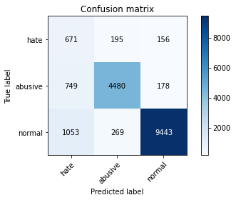

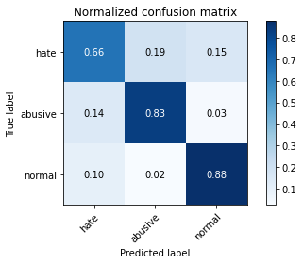

precision recall f1-score support

hate 0.27 0.66 0.38 1022

abusive 0.91 0.83 0.87 5407

normal 0.97 0.88 0.92 10765

accuracy 0.85 17194

macro avg 0.71 0.79 0.72 17194

weighted avg 0.91 0.85 0.87 17194

average eval_loss: 0.4487936738618585, accuracy: 0.8487844596952425

training 2 epoch...

237.45569348335266 seconds used......

2 training finished! average train loss: 0.43953764611859353

evaluating...

Confusion matrix, without normalization

[[ 782 99 141]

[1404 3870 133]

[1337 210 9218]]

Normalized confusion matrix

[[0.76516634 0.09686888 0.13796477]

[0.2596634 0.71573886 0.02459774]

[0.12419879 0.01950766 0.85629354]]

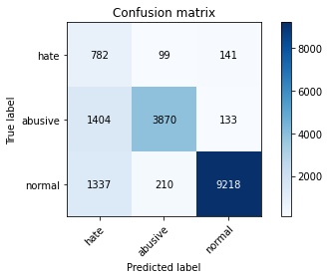

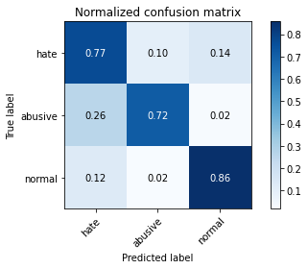

precision recall f1-score support

hate 0.22 0.77 0.34 1022

abusive 0.93 0.72 0.81 5407

normal 0.97 0.86 0.91 10765

accuracy 0.81 17194

macro avg 0.71 0.78 0.69 17194

weighted avg 0.91 0.81 0.84 17194

average eval_loss: 0.48241766575117445, accuracy: 0.8066767477026869

training 3 epoch...

237.36161255836487 seconds used......

3 training finished! average train loss: 0.30508002631248526

evaluating...

Confusion matrix, without normalization

[[ 733 131 158]

[1121 4052 234]

[1154 245 9366]]

Normalized confusion matrix

[[0.71722114 0.12818004 0.15459883]

[0.20732384 0.74939893 0.04327723]

[0.10719926 0.02275894 0.8700418 ]]

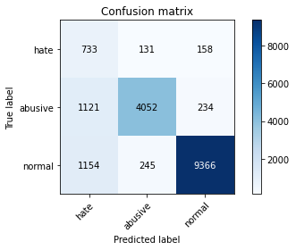

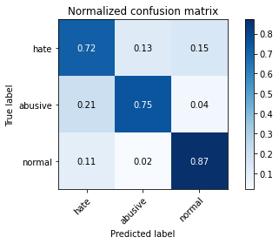

precision recall f1-score support

hate 0.24 0.72 0.36 1022

abusive 0.92 0.75 0.82 5407

normal 0.96 0.87 0.91 10765

accuracy 0.82 17194

macro avg 0.71 0.78 0.70 17194

weighted avg 0.90 0.82 0.85 17194

average eval_loss: 0.49195862701812454, accuracy: 0.8230196580202396

training 4 epoch...

237.67040467262268 seconds used......

4 training finished! average train loss: 0.20387716058212801

evaluating...

Confusion matrix, without normalization

[[ 772 119 131]

[1429 3835 143]

[1716 270 8779]]

Normalized confusion matrix

[[0.7553816 0.11643836 0.12818004]

[0.26428704 0.70926577 0.0264472 ]

[0.15940548 0.02508128 0.81551324]]

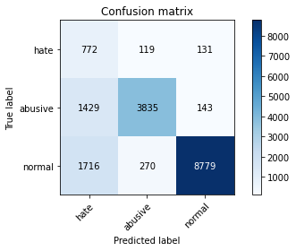

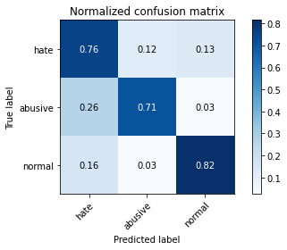

precision recall f1-score support

hate 0.20 0.76 0.31 1022

abusive 0.91 0.71 0.80 5407

normal 0.97 0.82 0.89 10765

accuracy 0.78 17194

macro avg 0.69 0.76 0.66 17194

weighted avg 0.90 0.78 0.82 17194

average eval_loss: 0.6887916976109494, accuracy: 0.7785273932767245

training 5 epoch...

237.85934615135193 seconds used......

5 training finished! average train loss: 0.13668961913175628

evaluating...

Confusion matrix, without normalization

[[ 727 155 140]

[1101 4128 178]

[1766 269 8730]]

Normalized confusion matrix

[[0.71135029 0.15166341 0.1369863 ]

[0.20362493 0.76345478 0.03292029]

[0.16405016 0.02498839 0.81096145]]

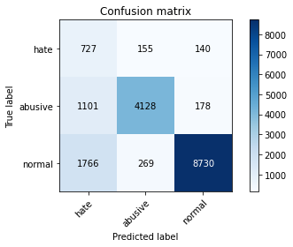

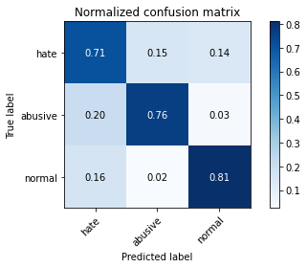

precision recall f1-score support

hate 0.20 0.71 0.31 1022

abusive 0.91 0.76 0.83 5407

normal 0.96 0.81 0.88 10765

accuracy 0.79 17194

macro avg 0.69 0.76 0.68 17194

weighted avg 0.90 0.79 0.83 17194

average eval_loss: 0.7995643121601884, accuracy: 0.7901011980923578

2 run...

training 1 epoch...

237.84040665626526 seconds used......

1 training finished! average train loss: 0.6099616764092284

evaluating...

Confusion matrix, without normalization

[[ 773 124 125]

[1184 4088 135]

[1638 267 8860]]

Normalized confusion matrix

[[0.75636008 0.12133072 0.1223092 ]

[0.2189754 0.75605696 0.02496763]

[0.15215978 0.0248026 0.82303762]]

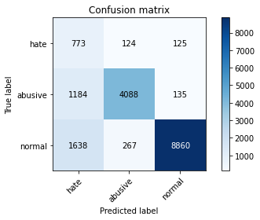

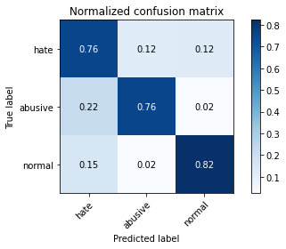

precision recall f1-score support

hate 0.22 0.76 0.33 1022

abusive 0.91 0.76 0.83 5407

normal 0.97 0.82 0.89 10765

accuracy 0.80 17194

macro avg 0.70 0.78 0.68 17194

weighted avg 0.91 0.80 0.84 17194

average eval_loss: 0.4934937715703665, accuracy: 0.7980109340467605

training 2 epoch...

237.9144446849823 seconds used......

2 training finished! average train loss: 0.4369927402375514

evaluating...

Confusion matrix, without normalization

[[ 799 91 132]

[1570 3713 124]

[1565 227 8973]]

Normalized confusion matrix

[[0.78180039 0.0890411 0.12915851]

[0.29036434 0.68670242 0.02293323]

[0.14537854 0.02108686 0.8335346 ]]

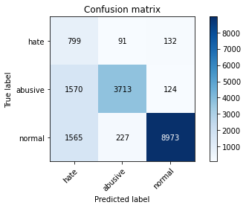

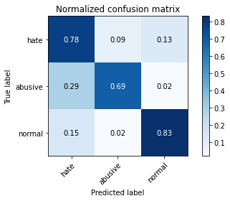

precision recall f1-score support

hate 0.20 0.78 0.32 1022

abusive 0.92 0.69 0.79 5407

normal 0.97 0.83 0.90 10765

accuracy 0.78 17194

macro avg 0.70 0.77 0.67 17194

weighted avg 0.91 0.78 0.83 17194

average eval_loss: 0.528686053132595, accuracy: 0.7842852157729441

training 3 epoch...

237.89736795425415 seconds used......

3 training finished! average train loss: 0.30246371202355854

evaluating...

Confusion matrix, without normalization

[[ 752 123 147]

[1275 3973 159]

[1332 287 9146]]

Normalized confusion matrix

[[0.73581213 0.12035225 0.14383562]

[0.23580544 0.73478824 0.02940633]

[0.12373432 0.02666047 0.8496052 ]]

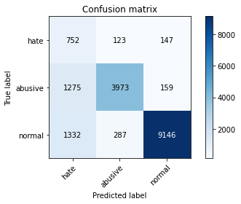

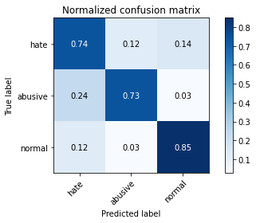

precision recall f1-score support

hate 0.22 0.74 0.34 1022

abusive 0.91 0.73 0.81 5407

normal 0.97 0.85 0.90 10765

accuracy 0.81 17194

macro avg 0.70 0.77 0.69 17194

weighted avg 0.90 0.81 0.84 17194

average eval_loss: 0.5575341993466366, accuracy: 0.8067349075258812

training 4 epoch...

237.77376532554626 seconds used......

4 training finished! average train loss: 0.18991686431501842

evaluating...

Confusion matrix, without normalization

[[ 701 174 147]

[1029 4213 165]

[1480 364 8921]]

Normalized confusion matrix

[[0.68590998 0.1702544 0.14383562]

[0.19030886 0.77917514 0.030516 ]

[0.13748258 0.03381328 0.82870413]]

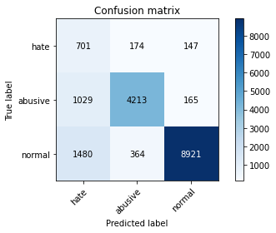

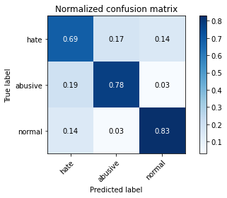

precision recall f1-score support

hate 0.22 0.69 0.33 1022

abusive 0.89 0.78 0.83 5407

normal 0.97 0.83 0.89 10765

accuracy 0.80 17194

macro avg 0.69 0.76 0.68 17194

weighted avg 0.90 0.80 0.84 17194

average eval_loss: 0.6999253789742672, accuracy: 0.8046411538908922

training 5 epoch...

237.97320914268494 seconds used......

5 training finished! average train loss: 0.13561276700368685

evaluating...

Confusion matrix, without normalization

[[ 660 206 156]

[ 943 4290 174]

[1411 338 9016]]

Normalized confusion matrix

[[0.64579256 0.20156556 0.15264188]

[0.17440355 0.79341594 0.03218051]

[0.13107292 0.03139805 0.83752903]]

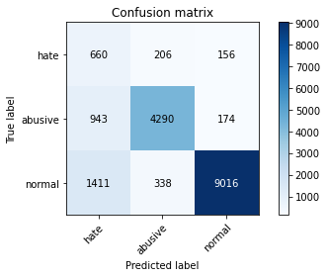

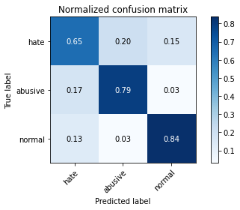

precision recall f1-score support

hate 0.22 0.65 0.33 1022

abusive 0.89 0.79 0.84 5407

normal 0.96 0.84 0.90 10765

accuracy 0.81 17194

macro avg 0.69 0.76 0.69 17194

weighted avg 0.90 0.81 0.84 17194

average eval_loss: 0.7070222151140834, accuracy: 0.8122600907293241

3 run...

training 1 epoch...

237.92013454437256 seconds used......

1 training finished! average train loss: 0.5998166411711454

evaluating...

Confusion matrix, without normalization

[[ 750 150 122]

[1018 4284 105]

[1490 335 8940]]

Normalized confusion matrix

[[0.73385519 0.14677104 0.11937378]

[0.18827446 0.79230627 0.01941927]

[0.13841152 0.03111937 0.83046911]]

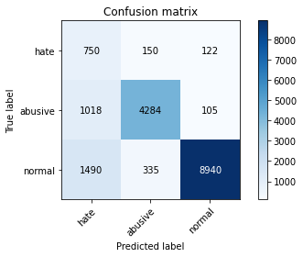

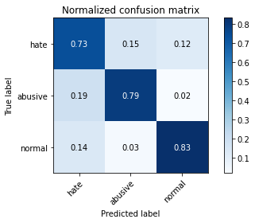

precision recall f1-score support

hate 0.23 0.73 0.35 1022

abusive 0.90 0.79 0.84 5407

normal 0.98 0.83 0.90 10765

accuracy 0.81 17194

macro avg 0.70 0.79 0.70 17194

weighted avg 0.91 0.81 0.85 17194

average eval_loss: 0.5049167058322319, accuracy: 0.8127253693148773

training 2 epoch...

237.89989304542542 seconds used......

2 training finished! average train loss: 0.4337811155694602

evaluating...

Confusion matrix, without normalization

[[ 729 134 159]

[1171 4086 150]

[1276 265 9224]]

Normalized confusion matrix

[[0.71330724 0.13111546 0.1555773 ]

[0.21657111 0.75568707 0.02774182]

[0.11853228 0.02461681 0.85685091]]

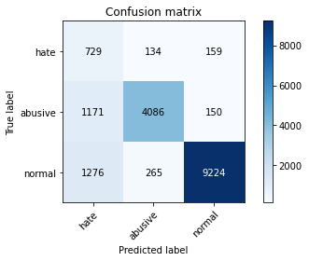

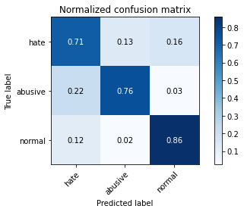

precision recall f1-score support

hate 0.23 0.71 0.35 1022

abusive 0.91 0.76 0.83 5407

normal 0.97 0.86 0.91 10765

accuracy 0.82 17194

macro avg 0.70 0.78 0.69 17194

weighted avg 0.91 0.82 0.85 17194

average eval_loss: 0.4574609668275645, accuracy: 0.8165057578224962

training 3 epoch...

237.85106468200684 seconds used......

3 training finished! average train loss: 0.3028487062195219

evaluating...

Confusion matrix, without normalization

[[ 805 89 128]

[1632 3622 153]

[1739 213 8813]]

Normalized confusion matrix

[[0.78767123 0.08708415 0.12524462]

[0.30183096 0.66987239 0.02829665]

[0.16154203 0.01978634 0.81867162]]

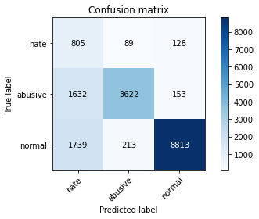

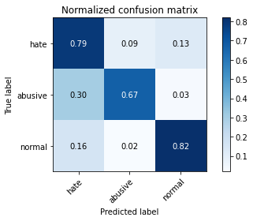

precision recall f1-score support

hate 0.19 0.79 0.31 1022

abusive 0.92 0.67 0.78 5407

normal 0.97 0.82 0.89 10765

accuracy 0.77 17194

macro avg 0.69 0.76 0.66 17194

weighted avg 0.91 0.77 0.82 17194

average eval_loss: 0.6442144561775549, accuracy: 0.7700360590903804

training 4 epoch...

237.8158106803894 seconds used......

4 training finished! average train loss: 0.195378262837655

evaluating...

Confusion matrix, without normalization

[[ 752 140 130]

[1183 4079 145]

[1755 334 8676]]

Normalized confusion matrix

[[0.73581213 0.1369863 0.12720157]

[0.21879046 0.75439245 0.02681709]

[0.16302833 0.03102647 0.80594519]]

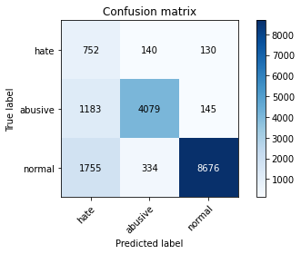

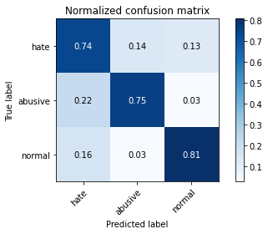

precision recall f1-score support

hate 0.20 0.74 0.32 1022

abusive 0.90 0.75 0.82 5407

normal 0.97 0.81 0.88 10765

accuracy 0.79 17194

macro avg 0.69 0.77 0.67 17194

weighted avg 0.90 0.79 0.83 17194

average eval_loss: 0.6727609909464454, accuracy: 0.7855647318832151

training 5 epoch...

237.8783872127533 seconds used......

5 training finished! average train loss: 0.13171031571394906

evaluating...

Confusion matrix, without normalization

[[ 797 107 118]

[1675 3592 140]

[2122 246 8397]]

Normalized confusion matrix

[[0.77984344 0.10469667 0.11545988]

[0.30978361 0.66432402 0.02589236]

[0.1971203 0.02285183 0.78002787]]

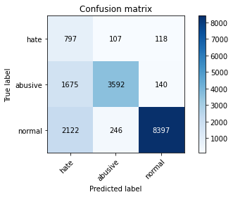

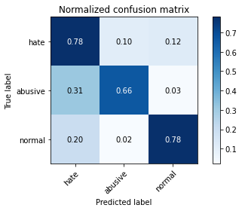

precision recall f1-score support

hate 0.17 0.78 0.28 1022

abusive 0.91 0.66 0.77 5407

normal 0.97 0.78 0.86 10765

accuracy 0.74 17194

macro avg 0.68 0.74 0.64 17194

weighted avg 0.90 0.74 0.80 17194

average eval_loss: 0.9898404069244862, accuracy: 0.743631499360242

4 run...

training 1 epoch...

238.07849073410034 seconds used......

1 training finished! average train loss: 0.6038749419135918

evaluating...

Confusion matrix, without normalization

[[ 796 88 138]

[1439 3810 158]

[1287 222 9256]]

Normalized confusion matrix

[[0.77886497 0.08610568 0.13502935]

[0.26613649 0.70464213 0.02922138]

[0.11955411 0.02062239 0.8598235 ]]

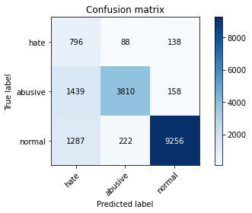

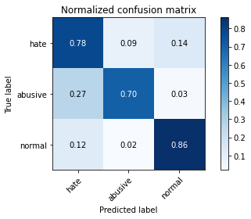

precision recall f1-score support

hate 0.23 0.78 0.35 1022

abusive 0.92 0.70 0.80 5407

normal 0.97 0.86 0.91 10765

accuracy 0.81 17194

macro avg 0.71 0.78 0.69 17194

weighted avg 0.91 0.81 0.84 17194

average eval_loss: 0.4640969523163729, accuracy: 0.8062114691171339

training 2 epoch...

237.86601161956787 seconds used......

2 training finished! average train loss: 0.4278127135662677

evaluating...

Confusion matrix, without normalization

[[ 715 135 172]

[1066 4160 181]

[ 985 266 9514]]

Normalized confusion matrix

[[0.69960861 0.13209393 0.16829746]

[0.19715184 0.76937303 0.03347512]

[0.09150023 0.02470971 0.88379006]]

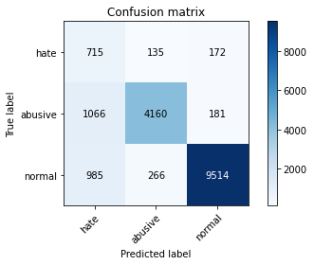

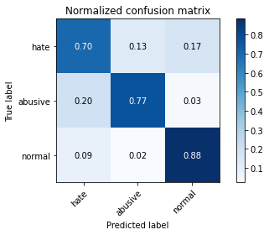

precision recall f1-score support

hate 0.26 0.70 0.38 1022

abusive 0.91 0.77 0.83 5407

normal 0.96 0.88 0.92 10765

accuracy 0.84 17194

macro avg 0.71 0.78 0.71 17194

weighted avg 0.91 0.84 0.86 17194

average eval_loss: 0.41642162746988065, accuracy: 0.8368616959404444

training 3 epoch...

237.86173796653748 seconds used......

3 training finished! average train loss: 0.30387312006499645

evaluating...

Confusion matrix, without normalization

[[ 581 209 232]

[ 663 4504 240]

[ 599 279 9887]]

Normalized confusion matrix

[[0.56849315 0.20450098 0.22700587]

[0.12261883 0.83299427 0.04438691]

[0.05564329 0.02591732 0.91843939]]

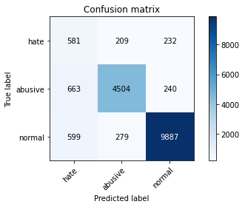

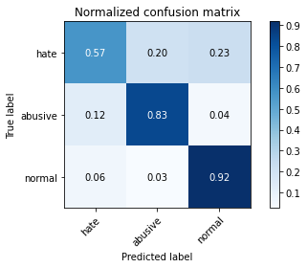

precision recall f1-score support

hate 0.32 0.57 0.41 1022

abusive 0.90 0.83 0.87 5407

normal 0.95 0.92 0.94 10765

accuracy 0.87 17194

macro avg 0.72 0.77 0.74 17194

weighted avg 0.90 0.87 0.88 17194

average eval_loss: 0.36066140803660074, accuracy: 0.8707688728626265

training 4 epoch...

237.8694088459015 seconds used......

4 training finished! average train loss: 0.20014232096659612

evaluating...

Confusion matrix, without normalization

[[ 662 175 185]

[1020 4185 202]

[1019 299 9447]]

Normalized confusion matrix

[[0.64774951 0.17123288 0.18101761]

[0.18864435 0.77399667 0.03735898]

[0.09465862 0.0277752 0.87756619]]

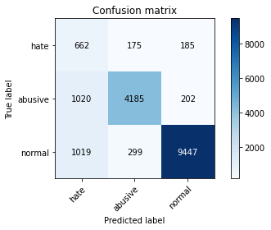

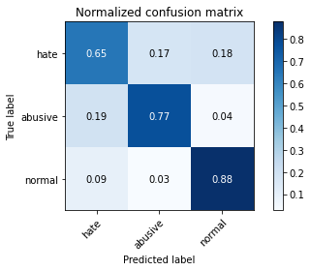

precision recall f1-score support

hate 0.25 0.65 0.36 1022

abusive 0.90 0.77 0.83 5407

normal 0.96 0.88 0.92 10765

accuracy 0.83 17194

macro avg 0.70 0.77 0.70 17194

weighted avg 0.90 0.83 0.86 17194

average eval_loss: 0.5532549858223214, accuracy: 0.8313365127370013

training 5 epoch...

237.84465050697327 seconds used......

5 training finished! average train loss: 0.12848192857658283

evaluating...

Confusion matrix, without normalization

[[ 740 152 130]

[1220 4006 181]

[1722 254 8789]]

Normalized confusion matrix

[[0.72407045 0.14872798 0.12720157]

[0.22563344 0.74089144 0.03347512]

[0.15996284 0.02359498 0.81644217]]

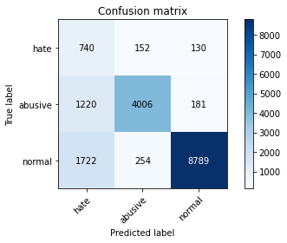

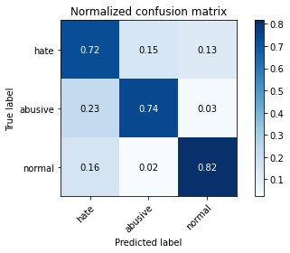

precision recall f1-score support

hate 0.20 0.72 0.31 1022

abusive 0.91 0.74 0.82 5407

normal 0.97 0.82 0.88 10765

accuracy 0.79 17194

macro avg 0.69 0.76 0.67 17194

weighted avg 0.90 0.79 0.83 17194

average eval_loss: 0.7939876281634666, accuracy: 0.7871932069326509

5 run...

training 1 epoch...

237.8870813846588 seconds used......

1 training finished! average train loss: 0.6207592492380745

evaluating...

Confusion matrix, without normalization

[[ 810 98 114]

[1390 3904 113]

[1897 254 8614]]

Normalized confusion matrix

[[0.7925636 0.09589041 0.11154599]

[0.25707416 0.722027 0.02089883]

[0.17621923 0.02359498 0.80018579]]

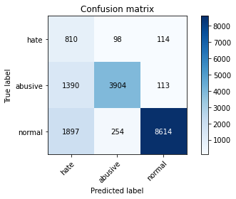

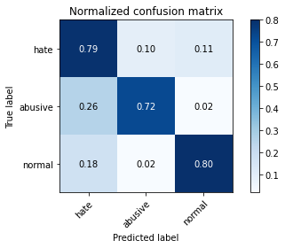

precision recall f1-score support

hate 0.20 0.79 0.32 1022

abusive 0.92 0.72 0.81 5407

normal 0.97 0.80 0.88 10765

accuracy 0.78 17194

macro avg 0.70 0.77 0.67 17194

weighted avg 0.91 0.78 0.82 17194

average eval_loss: 0.562005708990402, accuracy: 0.7751541235314645

training 2 epoch...

237.91725850105286 seconds used......

2 training finished! average train loss: 0.43610761245674795

evaluating...

Confusion matrix, without normalization

[[ 760 150 112]

[1093 4198 116]

[1825 250 8690]]

Normalized confusion matrix

[[0.74363992 0.14677104 0.10958904]

[0.20214537 0.77640096 0.02145367]

[0.16953089 0.02322341 0.8072457 ]]

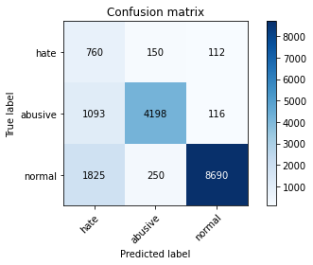

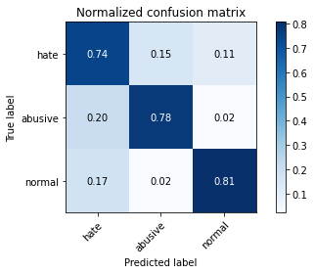

precision recall f1-score support

hate 0.21 0.74 0.32 1022

abusive 0.91 0.78 0.84 5407

normal 0.97 0.81 0.88 10765

accuracy 0.79 17194

macro avg 0.70 0.78 0.68 17194

weighted avg 0.91 0.79 0.84 17194

average eval_loss: 0.5352498490969803, accuracy: 0.7937652669535885

training 3 epoch...

237.90825152397156 seconds used......

3 training finished! average train loss: 0.31041361475636675

evaluating...

Confusion matrix, without normalization

[[ 770 149 103]

[1230 4080 97]

[2103 437 8225]]

Normalized confusion matrix

[[0.75342466 0.14579256 0.10078278]

[0.22748289 0.7545774 0.01793971]

[0.19535532 0.04059452 0.76405016]]

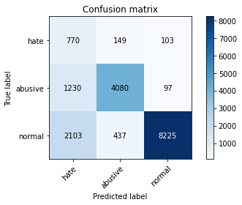

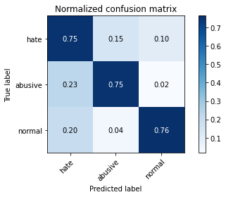

precision recall f1-score support

hate 0.19 0.75 0.30 1022

abusive 0.87 0.75 0.81 5407

normal 0.98 0.76 0.86 10765

accuracy 0.76 17194

macro avg 0.68 0.76 0.66 17194

weighted avg 0.90 0.76 0.81 17194

average eval_loss: 0.737516172923321, accuracy: 0.7604396882633476

training 4 epoch...

238.00864362716675 seconds used......

4 training finished! average train loss: 0.1936548859906923

evaluating...

Confusion matrix, without normalization

[[ 720 166 136]

[1141 4139 127]

[1481 344 8940]]

Normalized confusion matrix

[[0.70450098 0.16242661 0.13307241]

[0.21102275 0.76548918 0.02348807]

[0.13757548 0.03195541 0.83046911]]

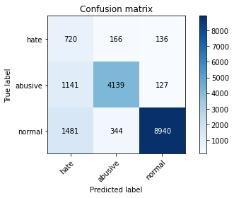

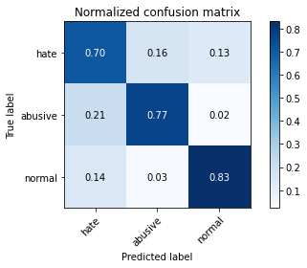

precision recall f1-score support

hate 0.22 0.70 0.33 1022

abusive 0.89 0.77 0.82 5407

normal 0.97 0.83 0.90 10765

accuracy 0.80 17194

macro avg 0.69 0.77 0.68 17194

weighted avg 0.90 0.80 0.84 17194

average eval_loss: 0.6806115491597285, accuracy: 0.8025474002559032

training 5 epoch...

237.86612010002136 seconds used......

5 training finished! average train loss: 0.1283101829790571

evaluating...

Confusion matrix, without normalization

[[ 769 159 94]

[1314 4004 89]

[2897 330 7538]]

Normalized confusion matrix

[[0.75244618 0.1555773 0.09197652]

[0.24301831 0.74052155 0.01646014]

[0.26911287 0.0306549 0.70023223]]

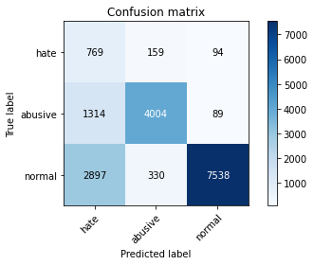

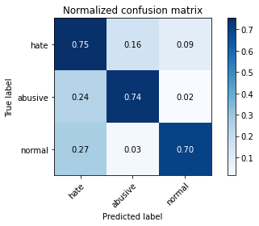

precision recall f1-score support

hate 0.15 0.75 0.26 1022

abusive 0.89 0.74 0.81 5407

normal 0.98 0.70 0.82 10765

accuracy 0.72 17194

macro avg 0.67 0.73 0.63 17194

weighted avg 0.90 0.72 0.78 17194

average eval_loss: 1.1869789820770884, accuracy: 0.7160055833430267